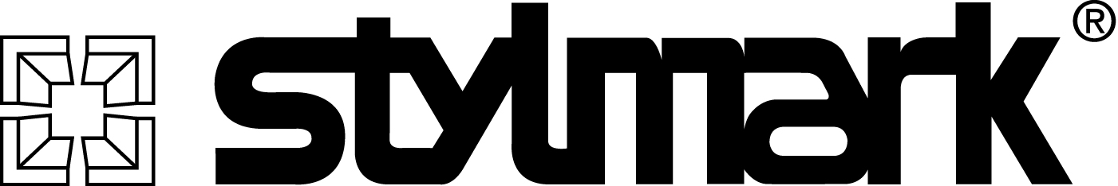

684208

NIGEL® 11/16” diameter

LED Showcase Reflector

Data Sheet
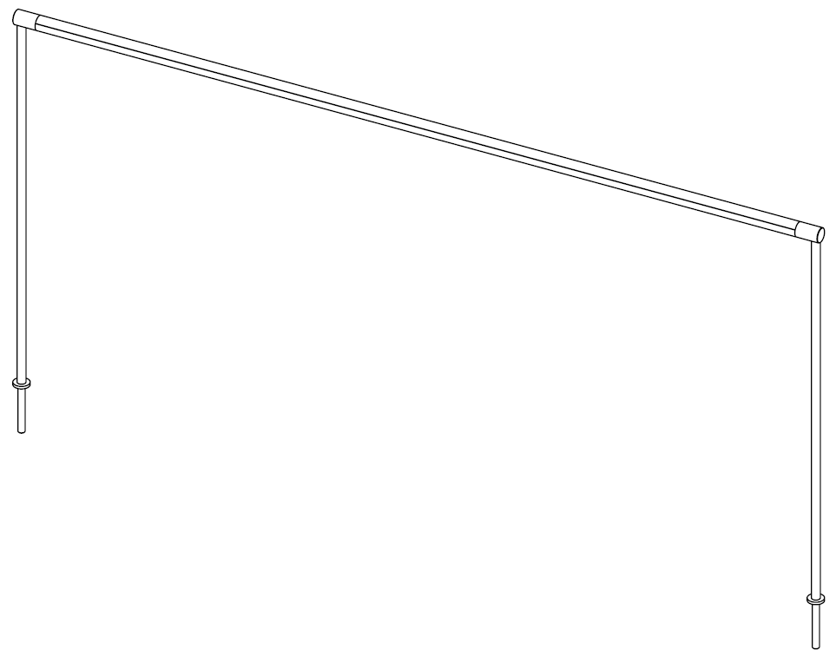

General Description: The Stylmark NIGEL® 11/16” diameter Showcase Reflector with Modular Light Engine is designed for commercial showcase displays that require a slim profile. Available in a variety of colors and finishes, the reflector can be mounted in wood end showcases using mounting hardware or in glass end showcases using down tube assemblies. Stylmark provides all hardware and electrical components for a finished assembly.

Performance Specifications:
Chromaticity¹:
Warm white: 3500K
White: 4000K
Cool white: 5000K

Illuminance²/Luminance:
Deluxe Light Engine: 270 f.c. / 500 lm/ft.
Premium Light Engine: 350 f.c. / 700 lm/ft.

Source:
Deluxe Light Engine: 21 LED/ft.
Premium Light Engine: 36 LED/ft.

Fixture Light Angle: 90°
Lamp Life: 70% lumen maintenance after 50,000 hours of continuous power on.
Dimmable: Compatible with 24Vdc, 2-wire PWM dimmers
Construction Specifications:
Materials: 11/16” dia. anodized aluminum extrusions
Sizes: Configurable (9” to 100” lengths)
Styles: Straight, Single Clipped, Double Clipped
Finishes: see Stylmark Color Library
Surface Temperature³: 110°F (43°C) max.
Mounting Options: □ Wood End Showcase Mounting, adjustable angle
□ Down Tube Mounting, adjustable angle⁴
□ with 1” O.D. washer
□ with 3/4” O.D. washer
□ None
Environmental Specifications:
Protection Rating: For indoor use only – approved for damp or dry locations
Temperature Range: 40 to 104°F (4 to 40°C)
Power Specifications⁵:
Input Voltage Requirement: 90~264Vac, 47~63 Hz
Power Consumption @24vdc (typical):
Deluxe Light Engine: 3.8 W per foot
Premium Light Engine: 6.7 W per foot

¹Nominal CCT Categories per ANSI_NEMA_ANSLG C78.377-2008 Specifications for the Chromaticity of Solid-State Lighting Products
²Measurements taken at midpoint of a 3’ 4000K fixture, 12” above showcase deck, with Konica Minolta Chroma Meter CL-200.
³Measured at ambient temperature of 72°F (22°C)
⁴End Caps and down tube assembly will be finished to match reflector
⁵LED reflector and power supply system, provided by Stylmark.



E257056

Low Voltage Lighting System,
UL 2108

Canadian Standard for General Requirements for Luminaires,
CSA C22.2 No. 9.0

Standard for LED Equipment for Use in Lighting Products, UL 8750

The aluminum reflector of the LED light fixture is fabricated to match custom dimensions. As the aluminum reflector also includes mounting hardware, the LED light assembly length will be less than the length of the aluminum reflector. Stylmark will configure the LED light assembly length to optimize the available space using Stylmark’s LED light engine modules. Please consult Stylmark for information specific to your order.

In order to continually improve our products, Stylmark reserves the right to make changes to specifications or materials without prior notice.

Stylmark Data Sheet: 684208 LED Showcase Reflector
Identification:

684208 – Straight Reflector
684228 – Single Clipped Reflector
684238 – Double Clipped Reflector

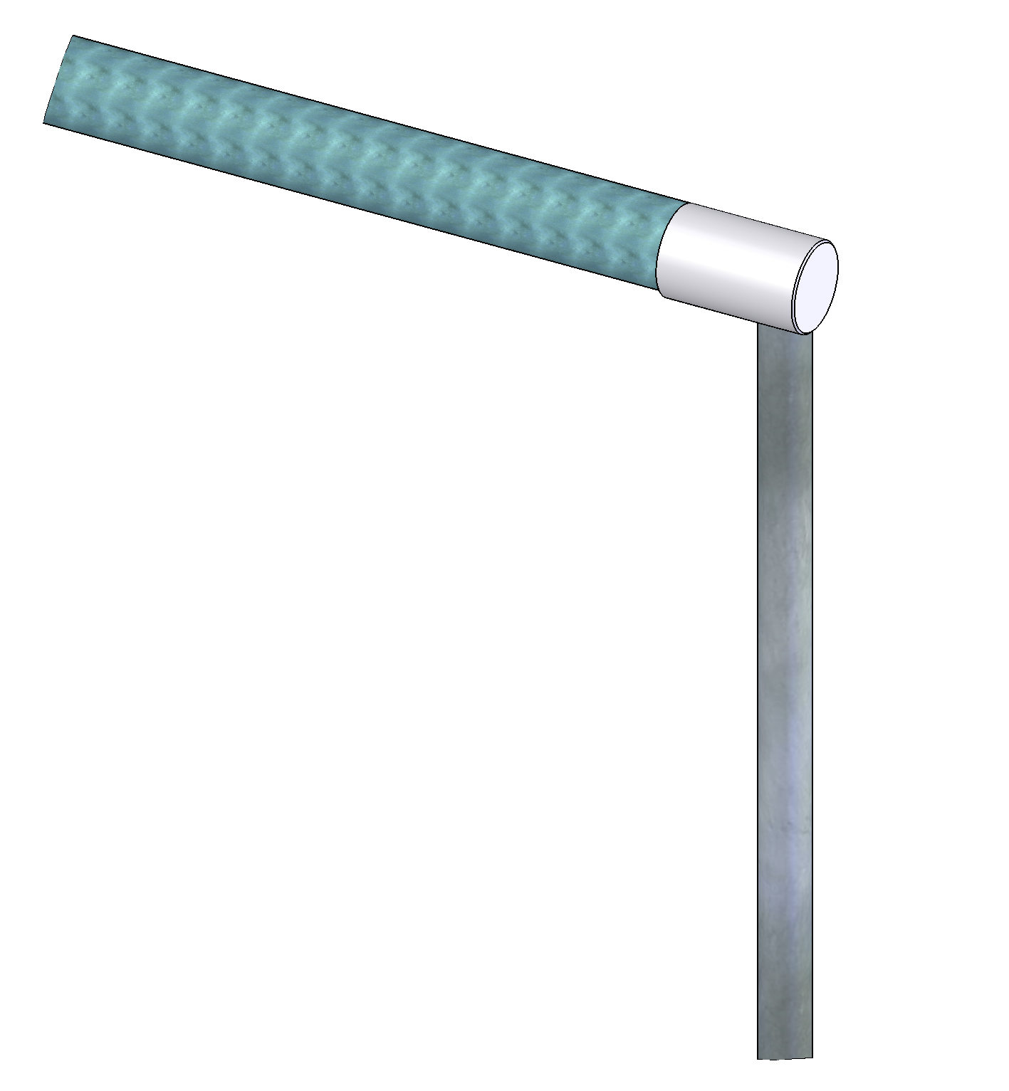

Adjustable Angle Glass End Down Tube

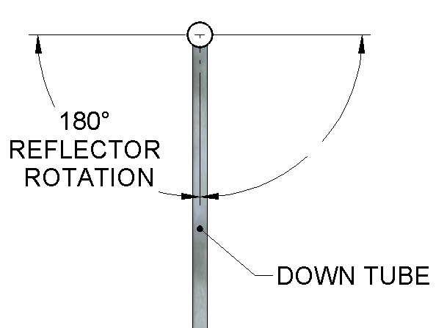

Typical Specification:
Showcase Reflector housing shall be constructed of anodized aluminum and shall be capable of being mounted either in wood end showcases using mounting hardware or in glass end showcases using rigid down tubes. Showcase Reflector LED shall provide a light cone angle of 90°. Showcase Reflector shall be available in Coordinated Color Temperature options of 5000K, 4000K or 3500K with chromaticity tolerances of less than 3 MacAdam steps. Showcase Reflector housing surface temperature shall not exceed 110°F (43°C). Showcase Reflector manufacturer shall provide all hardware and electrical components, including LED power supply kit, for finished assembly. Showcase Reflector shall be by Stylmark, Inc.

Mounting Options
Product Illustrations and Dimensions

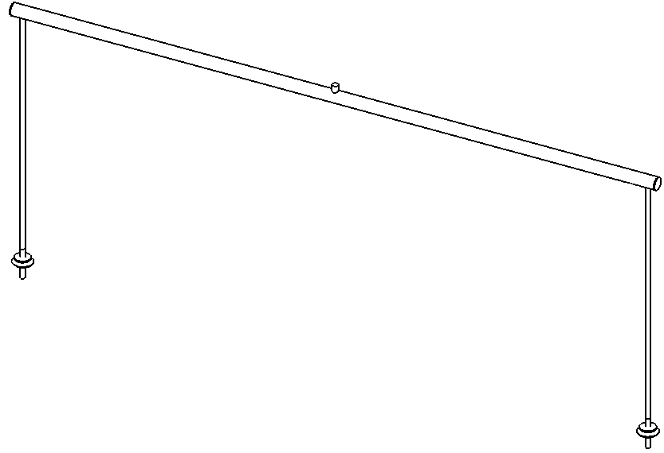
Straight Construction
- 684208 with down tubes shown

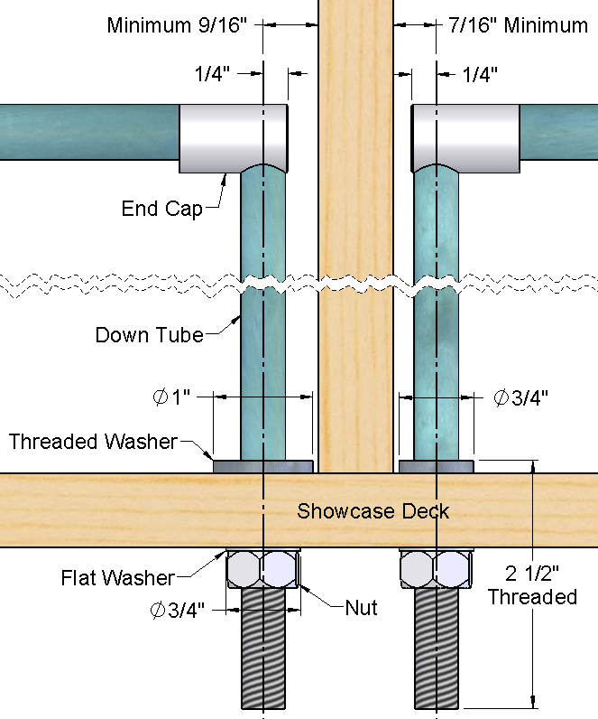
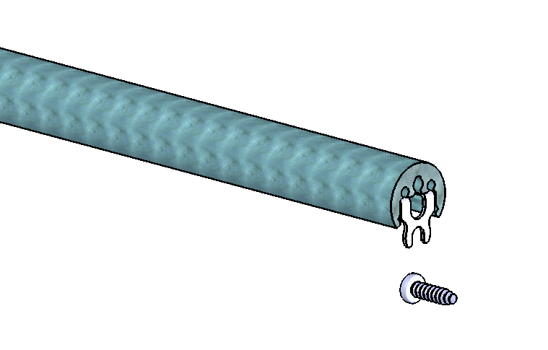

Wood End Mounting

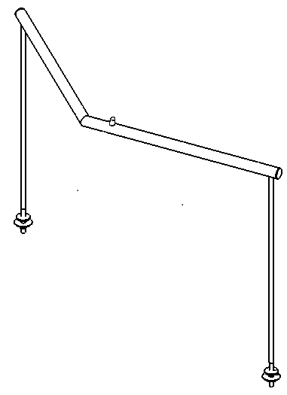
Single Clipped Construction

Power Supply Options
Part number of power supply supplied depends upon the number of LEDs in circuit. Verify power supply configuration with Stylmark.

- 684228 with down tubes shown
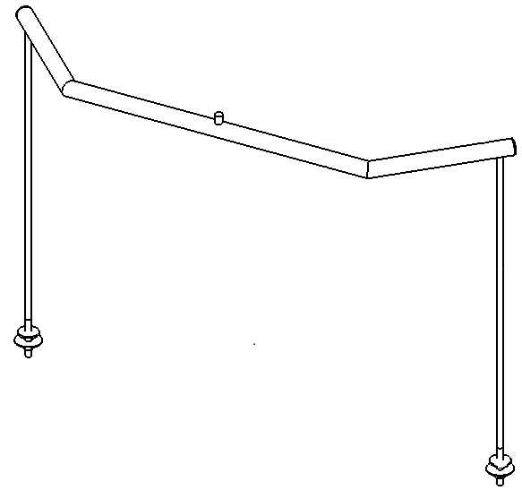

Double Clipped Construction
- 684238 with down tubes shown

Standard clipped corner angles: 90°, 135°
Standard fixture heights (with down tubes): 6” to 24”
Standard clipped wing lengths: 4” to 18”
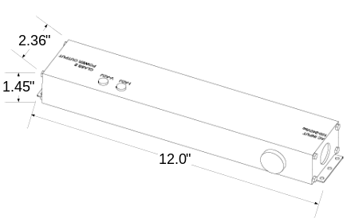

p/n 230572 60W
p/n 230573 96W

